# A Quiet Place – Survival of the Silent: Test Level Narrative

A Quiet Place – Survival of the Silent: Test Level Narrative 1

Overview 1

Start Menu 1

Set Up 1

Events and Points of Interest 1

## Overview

Users explore a non-interactive version of the barn living space from A Quiet Place. The building is the scene of a fight between one of the monsters and the surviving members of the family. Though the signs of struggle remain, the barn has been abandoned for some time.

## Start Menu

The start menu shows an exterior image of the barn by night*. Beneath it are the following lines of text:

* Select the barn to enter and explore
* You can leave the barn at any time by moving through the open doors

*This could just be a still from the film, doesn’t have to be a model. Alternatively it could be a close up model of the entrance exterior, with drapes over the open doorway.

## Set Up

After selecting the barn, the user transitions into the barn interior, where it is dark.

* Transition from menu to interior with a dark wipe, accompanied by the sound of white noise feedback, a monster shrieking, then a shotgun blast
* Inside the barn is silent, and the main light source is the user’s torch, ambient moonlight comes in through the windows along the wall on the bottom left side of the diagram (see later). All it should really do is outline indistinct masses of furniture and other set dressing
* Ambience should be tense and claustrophobic. The only sound is a very faint, occasional drip of water from the fruit cellar

## UI and controls

The UI will be kept to a minimum for this, just a small, unobtrusive cursor for the purpose of making teleport jumps.

* Locomotion can be roomscale, or stationary using the controller to navigate or to make very limited teleport jumps (distance TBC by testing)
* The user may only teleport to points on the floor of the barn, and should not be permitted to teleport anywhere that will result in them clipping through the geometry of the level
* The user will be confined to one plane of movement on the ground floor of the barn. They can look up at the hayloft, or down into the flooded cellar, but cannot enter either
* Objects are non-interactive and for display only in this test level. If the user collides with an object nothing happens, they will just have to move around it

## Events and Points of Interest

As the user navigates through the space, they will uncover signs of the fight, and area triggered audio and animation events will be set off. Unless otherwise stated, all events are one-off.

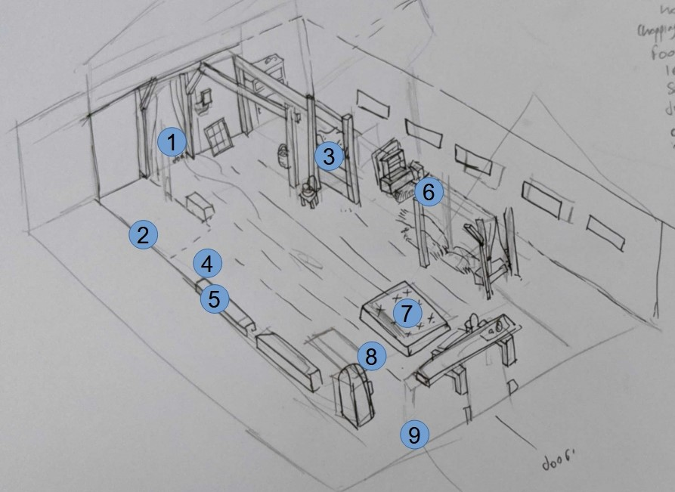

1. Entrance. When the user leaves, transition back to the main menu with a dark wipe*
2. Gouges slashed into the wall by monster claws
3. A cloth drape that flutters as the user passes by
4. Monster corpse**, initially appears as an unidentifiable huddle sprawled amidst the bales of the seating area. One of its arms is propped upright and covers its head. When the user approaches, the arm flops to the side with a soft thump, revealing its mutilated head. The armour plates are open and a large shotgun wound gapes in the soft tissue (and maybe feeding rats struggle from the hole and scatter). The straw and throws are stained with old blood. This should be a scare moment. It is important that the user is looking directly at this when it happens, so as well as an area trigger, the torchlight must be trained on it to trigger the event. After witnessing this, play sound of heavy breathing and thumping heartbeat, which slow and fade to silence after a few seconds
5. Shotgun pellet pattern in the wall next to a broken window
6. Whiteboard propped up in the art station area, with the following written on it in Sharpie: “WHITE NOISE STUNS THEM!!! Tools and equipment in main house basement. Safe room flooded, we can’t stay. Good luck and spread the word!”
7. Mattress half over the fruit cellar entrance. Looking down into it, the user can see it is almost full to the top with water. There is an occasional ambient drip from here, which is louder if the user is closer
8. Overturned dining table, which has been used as a makeshift barricade. Shotgun shell casings on the floor here
9. Racks of rotting, wilted vegetables. When the user approaches, a rat (or something, we don’t need to show what it is) moves at the back of a rack, disturbing the vegetables

*If we have time to do it, we could add one final scare here by having the screen cut to red, accompanied by the sound of an alien shriek and flesh tearing, indicating the user was killed on the way out.

**I realise this one is a lot of work, so if we can’t do it justice as the centrepiece of the experience in the time we’ve got, let’s just drop it.